The CoffeeNow App: Research

## Research Questions/Goals

From our proposal we were able to derive a variety of research questions including:

* Is there a geographic difference in coffee consumption?
* Who is the most likely to use an app to order coffee? Who is the least likely to use it?
* What are customer’s biggest complaints when buying coffee/tea/whatever from a coffee shop?
* What’s the average wait time for customers using the current system?
* How would people feel paying for coffee with their phones?
* How does the name “CoffeeNow” sit with customers? Do they like it? Does it get across the purpose of the app?

Our goal for the research phase of this project was to answer these questions.

## Process

In order to answer these questions quickly, completely and accurately we modeled our interview questions in a structured format. That way each of the questions was covered no matter the interviewer/interviewee combination. In all, our team conducted thirteen different interviews with six male and seven female respondents. For further consideration we also conducted three free-flow observations, to balance against the structure of the interview process.

The interviewees were roughly evenly divided by sex, allowing us to stay gender neutral. Furthermore, it made it possible to triangulate the commonalties between people of different genders in order to obtain a coherent consensus. Many of the interviews and observations were conducted during the week, although some occurring on the weekend.

Most interviews have taken place on the west coast due to resource and time constraints; however some interviewees were located on the east coast (via Skype).

### Compiled Interview Questions

* What are your biggest complaints when buying coffee (is it standing in line, the price, etc.)?
* About how many times a week do you typically buy coffee?
* How much time do you typically wait in line?
* And how long do you wait for it to be actually made?
* How often after ordering your drink do you actually spend in the café?
* How often do you order other things (sandwiches, muffins, etc.) when ordering your drink?
* Do you feel comfortable taking your time when ordering at the counter or do you feel rushed?
* (If rushed) Why?
* If there was an app that allowed you to build our own cup of coffee and place your order before arriving, would you use it?
* How do you feel about paying for coffee with your phone?
* Is the name CoffeeNow stupid? Can you do better?

### Inventory

Our inventory for the Research phase of our project included both Field Interviews and Field Observations. During the field interviews, we focused on people and how they felt about a coffee shop’s services (i.e. what they liked and what they didn’t) and asked of potential ways it might be improved.

We asked whether they thought that their overall experience might be improved if the CoffeeNow app were available for them to use.

For the observations we primarily focused what individuals were doing (i.e. how they were interacting with the various objects within their environment). Additionally, we looked at whether what they were doing was related to their current task in a given situation. Finally, we attempted to discern how individuals felt about what was transpiring around them and describe their various reactions to any stimuli within their environment.

## Documentation/Evidence (Detailed Observations and Interviews)

### Field Interviews

*What are your biggest complaints when buying coffee (is it standing in line, the price, etc.)?*

1. Waiting definitely, also I’d like it if the prices were more reasonable, especially on campus.
2. Biggest concerns for me when I get coffee is the price and quality of the coffee. I definitely want the best quality at the lowest price. I like Starbucks, but I can’t afford to be there everyday. I will buy cheaper coffee like when I buy gas, I go into Chevron to get a cup, or go to 7-11 in the morning, but they just help me get through the morning and not as good as Starbucks. And if I go grab some quick breakfast at a fast food place, I will get a cup of coffee.
3. The price as it is getting more and more expensive. The one I usually get is more than $3 a cup (e.g., vanilla latte or mocha).
4. Usually just the lines. Sometimes I don't have enough time to wait before an appt.
5. biggest complaint would have to be the high prices followed by standing in line
6. Usually the price. I'm fairly cheap, or at least I think I am. You know that. :) Other than that, I like buying coffee.
7. The price, definitely. Coffee shop coffee is over-priced and often overly sweet. Waiting in line is a bummer also but I guess ranks second to price.
8. For me personally, I’m one of those people that gets forgotten, I pay for it, I order it and then it never happens.
9. Getting stuck behind people ordering fancy drinks, so for them to order quickly for my consideration.
10. There isn’t enough information about what each of the drinks are.
11. Mostly, standing in line. There are a lot of coffee drinkers at the time I go, usually 8 to 10 people when I get in line. I know when I go to my coffee shop I’m going to be in a long line.
12. Having to get out of the car, and the prices.
13. Waiting for my coffee after I’ve ordered it

*About how many times a week do you typically buy coffee?*

1. It depends on how I’m feeling; I’m actually trying to cut back. On average it’s about 2 -3 times a week.
2. I would say I buy coffee 4-5 times a week, maybe 1 or 2 times from Starbucks.
3. I usually make my own coffee. I only buy coffee one or two times a week. Or I will buy if I don't have a coffee with me on weekend.
4. Typically 3-5 times a week.
5. I buy coffee/tea maybe once a week. I brew my own at home for the most part. But occasionally treat myself
6. Usually 2-4 times.
7. Probably about once per week max, maybe once every two weeks.
8. 5 or 6 times.
9. 3 or 4 times a week.
10. Probably once every other week, we have an instant coffee maker at work.
11. I usually go in 2 to 3 times a week.
12. Um depends on the week, sometimes 1, sometimes every day
13. 0-1

*How much time do you typically wait in line?*

1. Usually about three minutes.
2. Waiting in line is not a big deal for me, its waiting for them to make the coffee that could take a while. I would say I wait for no more than 3 mins in line to pay when I go to Starbucks, but I may wait another 4 or 5 mins for them to make the coffee and get it in my hands. It’s about the same when I go to a fast food joint to grab breakfast and coffee. When I go to the gas station or 7-11, it takes me a couple mins for me to get my coffee because it’s self serve and maybe another 1 or 2 mins to pay if there is a line.
3. 5 minutes.
4. This varies as well. Sometimes less than 2-3 min. Other times it can be closer to 15 min
5. I am usually in line about 5 mins or so.. unless I am in disneyland and waiting at starbucks turns into 20 mins.
6. About 1-2 minutes.
7. Usually 5 minutes or less.
8. No more than 5 minutes.
9. Maybe 3 minutes, but it feels like it could be less.
10. They are usually pretty quick, except for the one by my office, and I won’t wait for more than 5 minutes.
11. I’ll probably be in line for about 20 to 25 minutes.
12. 1 to 5 minutes of hell
13. Generally in line for at least 5-10 minutes

*And how long do you wait for it to be actually made?*

1. About two minutes.

*How often after ordering your drink do you actually spend in the café?*

1. It depends, most of the time I’ll grab a seat right here in the Atrium, unless I have class.
2. I never stay around the café or restaurant because I’m usually heading to work. I drink it in the car and when I get to work.
3. I rarely spend time in a cafe.
4. Typically I do the drive-thru unless I am meeting someone there specifically.
5. usually after getting the coffee i ordered I usually leave the cafe right after
6. Usually about 1 hour. On occasion, I'll stay 30 mins or leave right after.
7. If I am meeting a friend to chat, I will stay for hours. If I am going there to work, I will stay for hours. Other than that, it's in and out. So, either several hours, or zero minutes.
8. Usually like an hour to two hours, typing or doing homework/drawing.
9. Usually not any time.
10. Sometimes I’ll spend 20 minutes or so in the shop.
11. I’ll stick around to read the paper, spending 25 to 30 minutes in the café.
12. I don't go to Cafes, remember, I don't like getting out of the car... and if I do I don't hang around unless I am there to visit a friend
13. 0 minutes

*How often do you order other things (sandwiches, muffins, etc.) when ordering your drink?*

1. Not very often, the coffee is expensive enough.
2. At Starbucks, I only order a drink. Most of the time when I am at the gas station or 7-11, I will get the coffee only unless I see a donut or something that catches my eye, which would happen maybe once every other week or so. If I’m at a fast food restaurant, I’m usually there because I want some food as well, like a breakfast sandwich.
3. I don't order other things besides coffee
4. Maybe 25% of the time, if that.
5. About every 3rd or 4th order.
6. Maybe 25% of the time.
7. I’d say half of the time, so 3 times a week.
8. Less than once a week.
9. Usually not.
10. Most of the time no, there are the few occasions when I buy a pastry or something.
11. Um pretty much never
12. Almost never.

*Do you feel comfortable taking your time when ordering at the counter or do you feel rushed?*

1. Most of the time I feel comfortable, I usually figure out what I want while I’m in line.
2. I usually know what I want already. If I don’t, I won’t line up yet until I see the menu, unless there’s a long line. I try not to change my mind by the time I get to the counter because I hate to hold up the line. I don’t feel rushed because of the employees at the store, but I don’t want to hold up the line because there are people behind me that might need to get to work on time too.
3. Sometimes I feel rushed. If I'm rushed and the line is long, I will just leave.
4. I usually don't feel as rushed at the drive-thru. I feel more rushed inside at the counter.
5. Always rushed. Always fumbling for my virtual money. Except at Dutch Brother's when I'm in my car, then I don't feel rushed unless people are behind me.
6. If there are people in line behind me or if I am in a hurry, then I feel rushed.
7. I don’t feel rushed, the place I go to has very laid-back people.
8. I do not feel rushed, possibly since I just order a black coffee.
9. I usually feel rushed at the counter, I just don’t know enough about the choices.
10. I feel a bit rushed because I don’t have the lingo down yet, like “half-caff”. Just because of that I haven’t branched outside of my regular drink.
11. I feel rushed, and like I am saying it all wrong! Haha
12. I feel rushed. Unless I’m ordering a plain cup of coffee…(am I weird that I do that?)

*(If rushed) Why?*

1. The line is long.
2. If there is a long line, people (both customers and workers) are anxious for you to get going and make it quick. You don't notice this as much in the drive thru.
3. I feel rushed if there is a long line behind me, I'm afraid they are getting irritated at me. If I'm already running late, then I am worried about being later.
4. Because I never know exactly what I want, or how to order it and get what I really want.
5. Wtf is a caramel mustard echo machicatto? Do I want the special? The people behind the counter talk too fast.

*If there was an app that allowed you to build our own cup of coffee and place your order before arriving, would you use it?*

1. If the app was offered free by the coffee house, then I could see myself using it.
2. Sometimes, if I know I will go to that specific store and know what I want because the morning routine might change from day to day. And it might be hard to use the app on the phone while I’m driving. Besides, I don’t think we are suppose to use our phone while driving.
3. It's a good idea. I'll definitely try if there's an app for ordering coffee ahead of time. So save time and no need to wait in line.
4. Absolutely.
5. When I am in disneyland and waiting at starbucks turns into 20 mins. was just there in December and man I wish I had this app you are making lol
6. I would try if it was free. It would seem a bit odd to show up and not have to order, so I'd have to get used to NOT ordering and figuring out where to go when I get there and whether my drink will still be hot. The timing would be a challenge too. What if I'm late, what happens? FAQ's would be in order, for sure.
7. Yes, I would.
8. Yeah, probably.
9. Yeah I could see that, it depends on the coffee shops that don’t have lines. But at another place with a long line I could see using that app.
10. Yeah I think so, I have the Starbucks app, but I don’t tend to use it. When I go to a coffee shop, its spur of the moment, if I went regularly, I might use the app to save on time in the line.
11. Yes, I would definitely use that.
12. YES!
13. Maybe. If it were free

*How do you feel about paying for coffee with your phone?*

1. Wouldn't bother me.
2. not a problem
3. Fine with it. I use my Starbucks app all the time. Of course, only if it's the same price I'd pay in the store.
4. I am slightly suspicious of new technologies. If it's like the thing where you wave your phone in front of a reader and it deducts it form your account, then I am suspicious. If it is just using the internet with your phone and paying via PayPal or something, I am less suspicious.
5. I actually don’t mind, if I trusted the software. Not opposed to technology.
6. I would want to be familiar with the network that was providing that service, (paypal). If it was a random app, then I probably would not use that service.
7. I would totally do that.
8. I do that now using the PassBook application on my iPhone.
9. I use my starbucks card on my phone all the time!
10. I haven’t paid for anything with my phone yet. I would do it if I had the technology (data plan).

*Is the name CoffeeNow stupid? Can you do better?*

1. It isn't stupid. Maybe myCoffee?
2. meh
3. I wouldn't say it's stupid. Definitely clever. I can't do better right now though, but if you have other ideas, I'd be glad to hear 'em. :)
4. I like it.
5. No, it’s a pretty good title, its simple. It is what it is, you don’t want to be too fancy. Definitely want that word “coffee” in there.
6. I feel like that’s a solidly middle of the road name, don’t have feelings for or against it. Less literal perhaps.
7. I feel like we all know what Coffee is, it’s that thing you drink that’s nutty, brown, etc. But you never see a coffee shop that’s called “The Coffee Shop”, they try to dress it up using things like “Java” or “Bean”. “Coffee” may be too generic, like a commodity.
8. I think it’s appropriate from the basis of the questions, getting your coffee without the intimidation factor of having to know what you want to order.
9. The name works, or at least I can't come up with anything better...
10. That depends on your opinion of stupid…no, but here’s what I thought of in a couple of minutes…I don’t think they are any better than CoffeeNow. Instant Joe, Joe, Java Lava, GMMFCN. (give me my freaking coffee now). Mycup. Ejava, Ejoenow, Happy Happy JO JO, Easycupojoe, Lovecoffee

### Observations:

#### 1/25/2013 @ Starbucks, Newport Coast CA

* Man with glasses, mid 50s wearing a leather jacket waited in line for 3 minutes, when paying an espresso pulled out his smart phone to check something, paid with a credit card. Walked over

to receiving area, then walked to the restroom while his drink was being made. When he comes

out, gathers his drink, checks out the paper on his way to the fixings table. Pours in sugar,

comes back to the barista and asks for his breakfast sandwich near the back of the line. Takes

both and sits down to eat and drink @10:20. Plugs in headphones to his smart phone while

eating. @10:36 man zips up his coat and walks out, leaving behind his plate and empty shot

glass.

* 10:24 Young girl, mid 20s wearing a knitted hat and boots, looks at her iPhone while waiting in

line, 30 seconds. Orders a pastry and drink, pays for it using a credit card. With no wait for her

drink, she receives it after 3 minutes while nibbling on the pastry. Takes drink and leaves.

* At 10:25, there are 7 smartphones in the café, with 8 people here. However, no customers have

paid using their smartphones.

* 10:30 Older woman, mid 40s/early 50s having a ponytail and wearing a sweater orders a large

iced drink and breakfast sandwich. Pays using cash, no indication of having a smartphone. Waits

for her drink for 2 minutes by the fixing table. Grabs a straw and leaves.

* 10:32, 40 year old guy wearing a wool hat and plaid shirt walks in with his hands in his pockets orders his drink paying with credit card. Walks to the newspaper stand and picks one up reading for 30 seconds, then puts the paper back. Waits two minutes for an in iced drink, grabs a straw

and leaves.

* 10:34, 55 year old man wearing a button down shirt orders a drink, grabs a banana, and pays for

it with cash. Talks to the barista for a few minutes before handing her a business card. He

seems to have a rapport with the barista. Waits for his drink and leaves.

* 10:38, 60 year old woman wearing earphones listening to her iPhone comes in with a younger

girl (granddaughter?) asks a question about a drink to the cashier. Girl wearing sparkly pants

looks at a Bruno Mars CD. Woman pays for a drink for herself and for young girl with her credit

card after a couple minutes. Talks to barista while making drink.

* 10:42 two men wearing dress shirts come in using smartphones. One pays for his drink using

cash, then stands by the newspaper stand shuffling back and forth waiting. After two minutes

of waiting, he grabs his drink then beelines for the door. Seemed to be in a rush, most likely

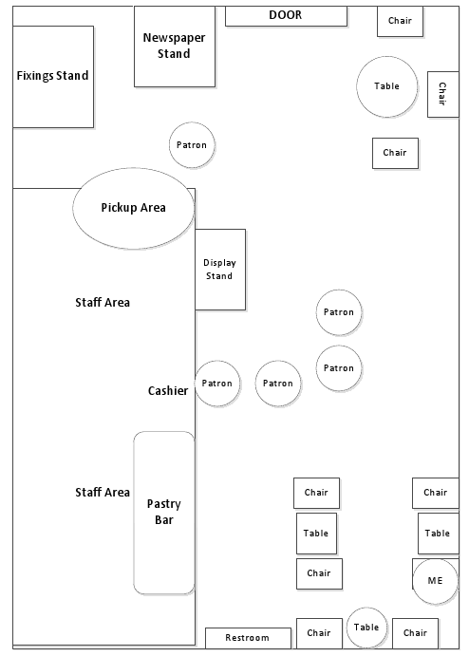heading back to work. The other pays for his drink using his smartphone(!!) before walking over

to the bathroom, tie in hand. Uses the bathroom for 2 minutes, comes back out wearing his tie.

Heads directly over to receiving area then out the door. Likely going to work for the first time today.

* 10:47 Man late-50s walks in wearing glasses and a dress shirt, waits 3rd in line while rubbing his

glasses with a cloth. Looks at the ordering board then around. Has a smart phone hanging from

his belt. Checks out the various pastries and sandwiches, now second in line. @10:49, quickly orders drink and pays for it with a credit card. As his heads over to the receiving area, he puts the card back into his wallet and pulls out his smartphone. Attention is now entirely on smartphone until his drink arrives. Gets drink and goes back to looking at smartphone. Must be waiting for a sandwich. Correction, had to finish something on his phone, then grabs a sleeve for his drink and walks outside. Stands outside for a minute sipping his drink before moving on.

* Spoke with cashier before leaving at 10:55, she says that about half the people who come in to order something are using their smartphones to pay for it. Early mornings perhaps?

#### 1/24/2013 @ Kelley Atrium “e-café”, Corvallis OR

The person who I decided to observe was a 20 year old female wearing rolled up jeans, a black rain coat, a backpack, and what looked like slippers. At 9:56am she walked up to the line in the coffee center. She was the 9th person in line (This is usually the busiest time). While she was standing in line she had both her hands in her rain coat pockets. While she was waiting she looked around and continuously shifted her weight from foot to foot (I think due to impatience) as if she had somewhere she needed to be. She pulled out her iPhone with a bright orange case for what I can only assume was to check the time. She then pressed a few buttons and it looked like she was reading something on her phone. It looked like emails or possibly texts. She then put her phone back into her front rain coat pocket, checked her hair and tugged on her pony tail. She put her hands back into her front rain coat pockets as she continued to move slowly forward. Next to her there was a stand with some fliers of upcoming events at OSU. She casually browsed them. As soon as she was next in line to place her order she began to look intently at the items within the glass case next to the counter.

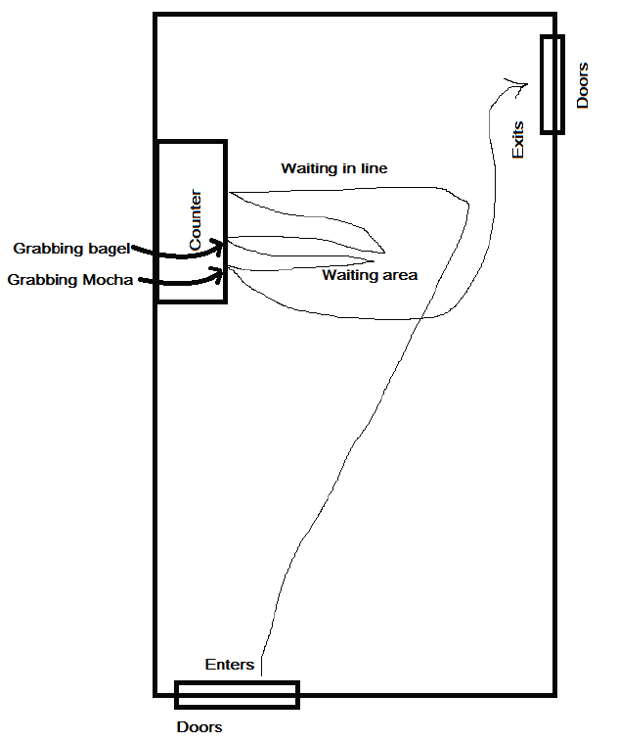When it was her turn to place her order, she ordered a medium white mocha and a bagel with cream cheese. She then pulled out a lime green change wallet and grabbed out her credit card to pay for the purchase. As soon as her credit card had been handed back to her, she put it back into the wallet and took the backpack off, placing the wallet back into it while walking to the waiting area to wait for her order. So at about 10:00am she pulled her out iPhone again and started texting (because her thumbs were moving really fast!). She looked like she was concentrating really hard on what she was writing when one of the people behind the counter called out, “Bagel with cream cheese!” When she heard that her head popped up and she grabbed the bagel and cream cheese on the counter. She then walked back to the waiting area. She stuck the bagel between her arm and her body and continued to read and text until she heard, “Medium white mocha!” Her head once again came up and she looked around like she wasn’t sure if it was for someone else. When she realized it was her drink she went up to the counter, put her iPhone back into the rain coat pocket and grabbed the mocha. The time was 10:05am when she grabbed it. She then proceeded to walk out of the coffee center at a semi-rapid pace. Thus, the total time for her order had been approximately 9 minutes 20 seconds. With approximately 4 minutes of waiting in line. With an additional 30 seconds to place her order and pay. As well as waiting 4 minutes and 30 seconds for her order to be completed.

#### 1/29/2013 @ Coffee Bean, Irvine CA

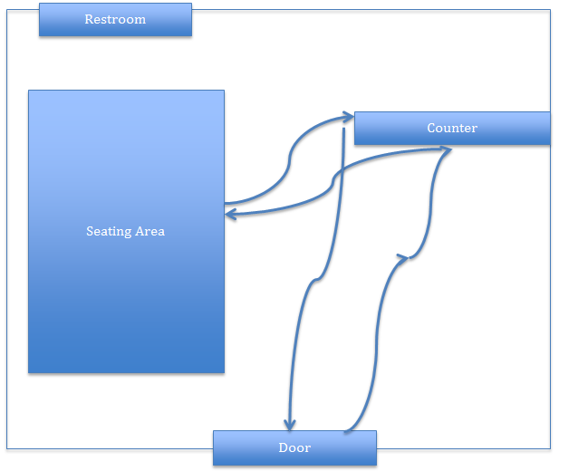The coffee shop that I went to is inside a large shopping plaza. It was a weekday afternoon. There weren’t many customers in the shop (there was a total of four customers, including myself). At 3:40PM, a woman who looks in her 50s came in. She was wearing a red sweater, black jeans, and a purse. There was a young man behind her. He looks in his early 20s. He was wearing a hoodie, blue jeans, and tennis shoes. They look like mother and son. I decided to observe them and their behavior.

Below is what I noted:

* There was no wait line.
* They smiled at the cashier before looking at the menu.
* The woman turned to the young man, asked him a question, then pointed to the menu.
* They started talking while still looking at the menu (I believe they were discussing their order).
* (About 1 minute later) They walked up to the cashier. The guy told the cashier what they wanted. The woman took out her wallet from her purse and paid by credit card.
* They walked away from the cashier and sat down in the seating area.
* While they were waiting for their order, the woman opened her purse and took out her phone. It is not a smart phone. She opened it, stared at the screen for a couple seconds, then closed it and put it back in her purse (Assumption: She probably wanted to check if she has any miss calls or new voice mail).
* The guy took out his iPhone from his pocket. He started playing with his phone.
* (3-4 minutes later) The cashier calls ,“Jeff.” Both the woman and man went up to her and picked up their order. They ordered 4 coffee drinks.
* They left the shop at about 3:55PM.

## Insights, or Our Key Findings:

- Price is the biggest concern, followed by wait time.

- On average, customers wait about 3-5 minutes in line.

**Insight:** Our app can help coffee shops improve their customer experience by reducing wait time.

- Few customers order other items (e.g., sandwich, muffins) besides coffee.

**Insight:**  This finding gives us an idea of what we can focus on in our app design (e.g., coffee menu or anything that is related to coffee drinks). It also suggests that non-coffee items are less likely to be viewed by customers and can be minimized or hidden from the screen.

- Regardless of geography, customers bought their coffee in largely the same manner

**Insight:** Our app can have a broad range of appeal by addressing the basic concerns already discussed, doesn’t need specific geographic targeting.

- All of our interviewees are interested in getting an app that allows them to order coffee from their phone, especially if the app is free.

**Insight:** Coffee lovers are likely to try a coffee app, but the cost of the app needs to be affordable. If possible, we should allow customers to download and use it for free.

- Most of our interviewees think it is fine to pay for coffee with their phone.

**Insight:** We need to make sure our app has no data security issues.

- Some interviewees liked the name “CoffeeNow”.

- Others were ambivalent or could not think of anything better.

- Still others did not like the name, or thought it lacked pizzazz.

- This question sparked more diversity of opinion than any other. For instance, one respondent said that the word “coffee” should definitely be in the name while another respondent said the word definitely should NOT be in the name.

**Insight:** App naming is pretty subjective, we can probably keep our app name as it is, but it wouldn’t hurt to explore alternatives.